Crop Production Analysis in India

1. Production in Top 3 State

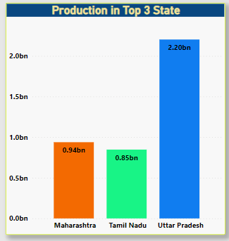

1. Total Area in Top 3 State

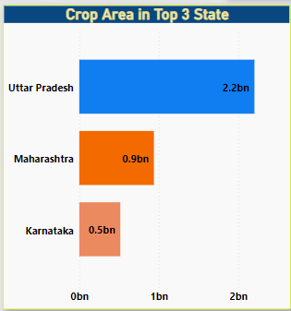

1. Area cover under each season

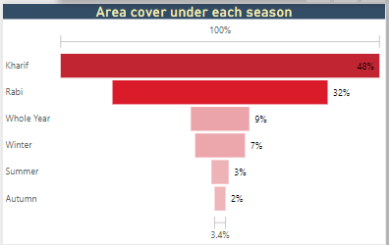

1. Top 10 Crops by Avg area , Avg Production , Area Ratio

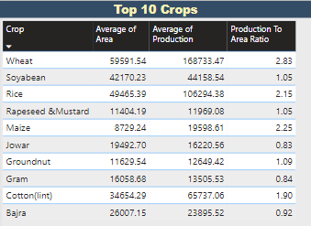

1. Top 10 States according to the area covered under cultivation.

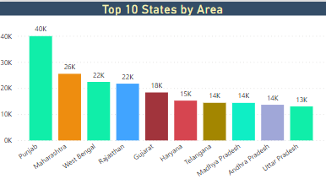

1. Crop category area and production

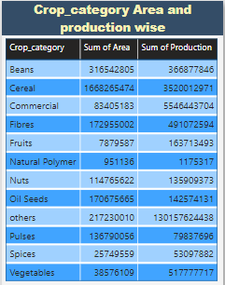

1. Distribution by Crop category

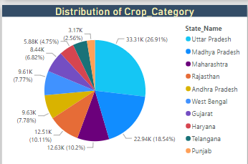

8. State wise area

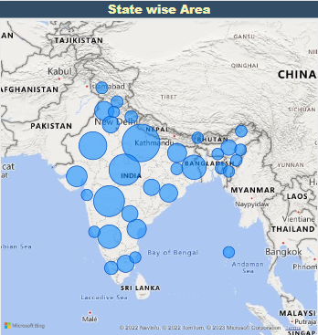

**Insights**

1. Total of **2953.79 million Hectares** area is cultivated till date in India.
2. The total food grain production in the country was recorded at **141176.12 million Tons.**
3. 51.19 % of Total area of India is under five crops viz. **Rice, Wheat, Cotton, Bajra and Jowar.**
4. Among the Top 5 crops above mentioned **Rice** has the highest percentage of 25.29%.
5. From year 1997 to 2015, **Year 2011** records the highest crop production which is

# 14,308.9 million Tons.

1. Whereas **Year 2013** records the second highest crop production after Year 2011 which is **12903.59 million Tons**.
2. All states and union territories in India produce **Cereals** which makes them the **most produced crop category** in India.
3. **Oil seeds, Pulses and Beans** are the second most produced crop category in India (32 States).
4. **47.56% of Total area** cultivated in India is under **Kharif Season** which shows that the Indian Environment is more suitable for the Kharif crops.
5. **32.09% of Total area** cultivated in India is under **Rabi Season** which makes it the second highest after the Kharif season.
6. The Indian environment is **least suitable** for the growth of crops which falls under

# Summer and Autumn Season.

1. **Top 10 cultivated states in India are as follows** –
   1. Punjab 2. Maharashtra 3. West Bengal 4. Rajasthan 5. Gujrat 6. Madhya Pradesh

7. Andhra Pradesh 8. Uttar Pradesh 9. Karnataka 10. Bihar.